Design

Initially, several design sketches were reviewed with the project owner. The initial understanding of the developer was that something kpi focused was wanted with several different windows where analytics could be viewed. The users wanted a simpler application with a more uniform feel and didn’t feel the need to have the kpi information. A second set of sketches was provided. Those sketches were accepted, and development began. During development some things were changed due to overlooked details, and user feedback after testing the feature but new sketches were not generated.

Initial sketches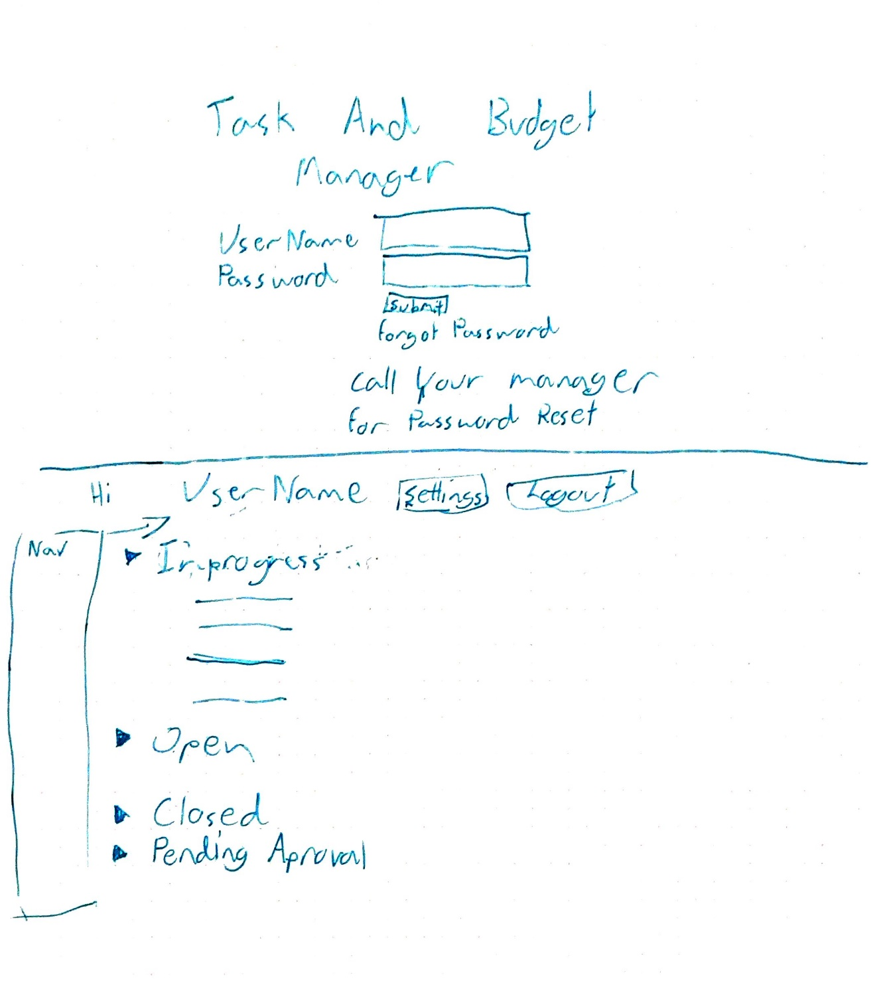

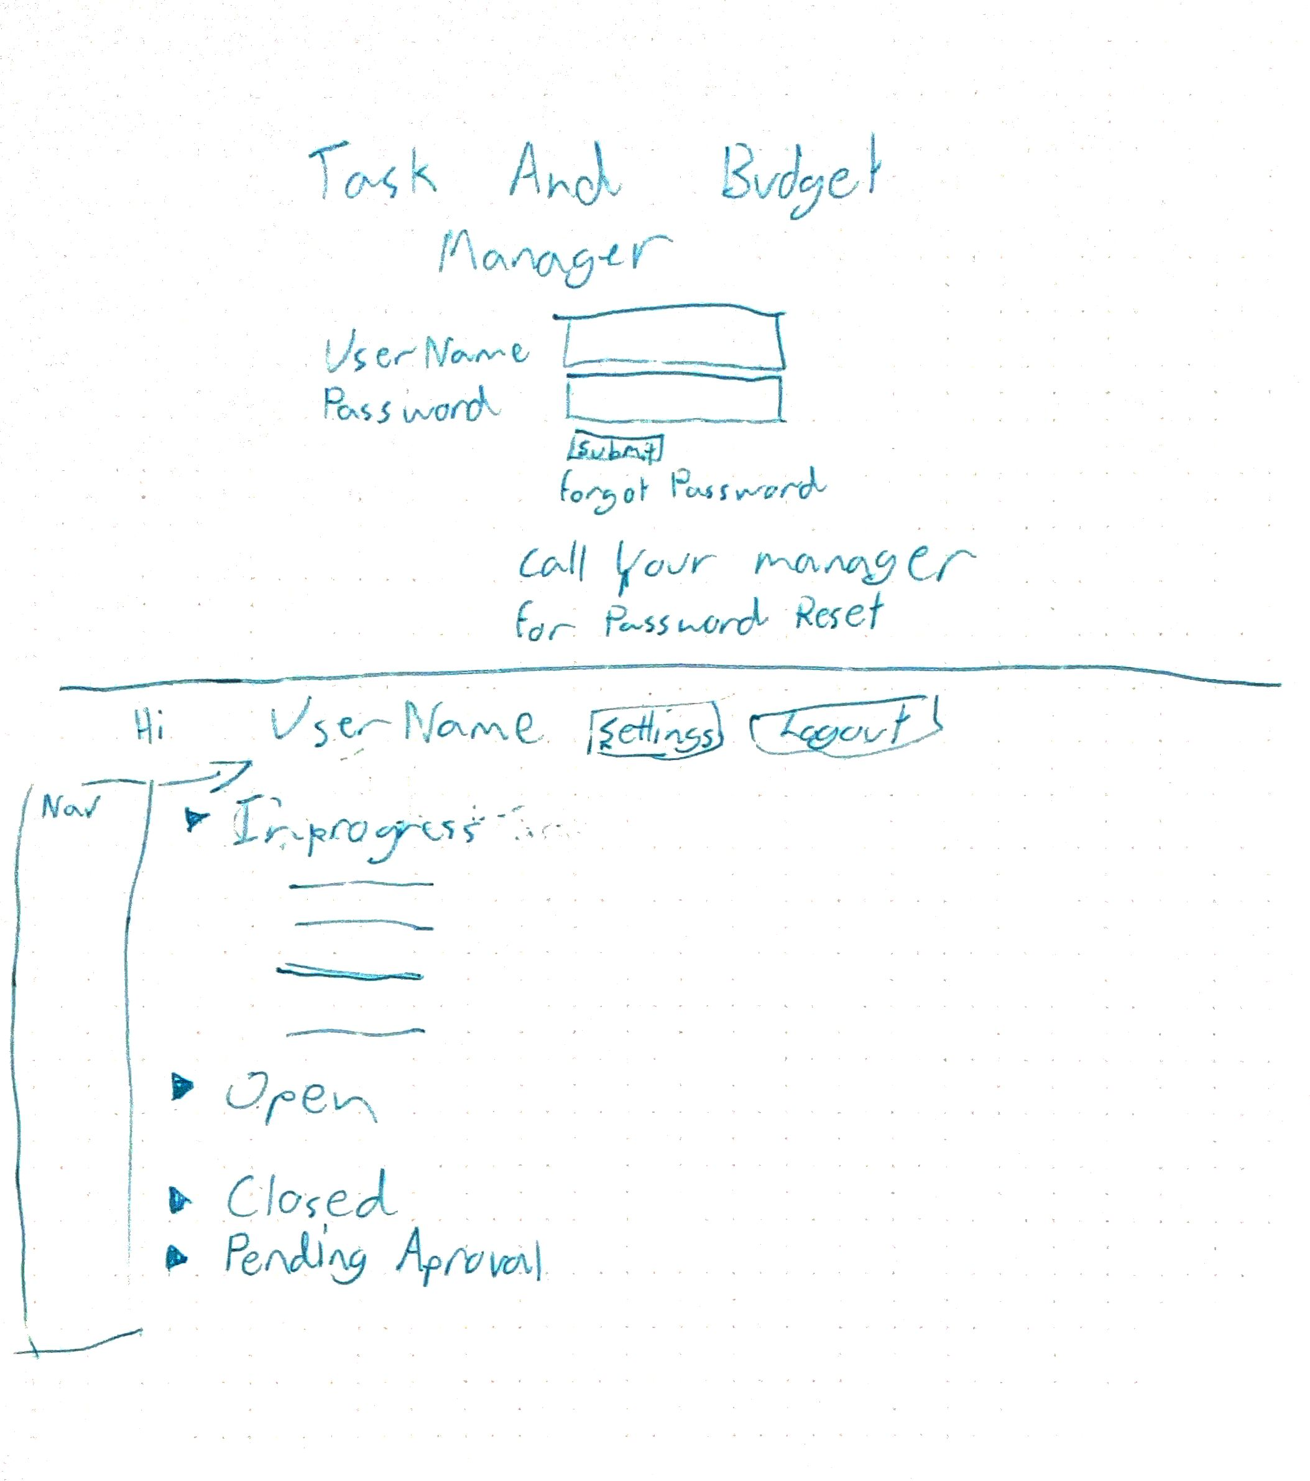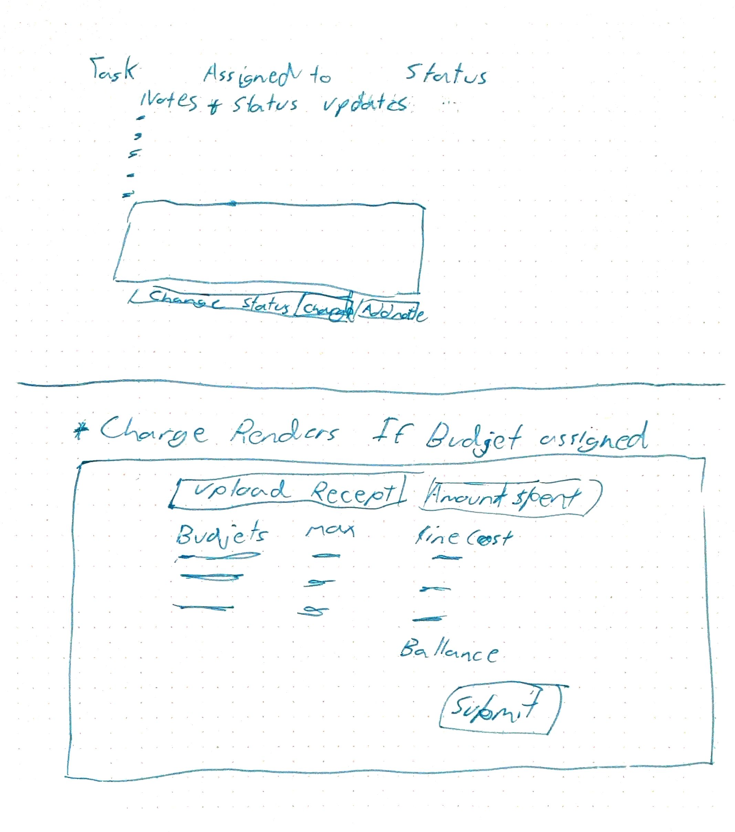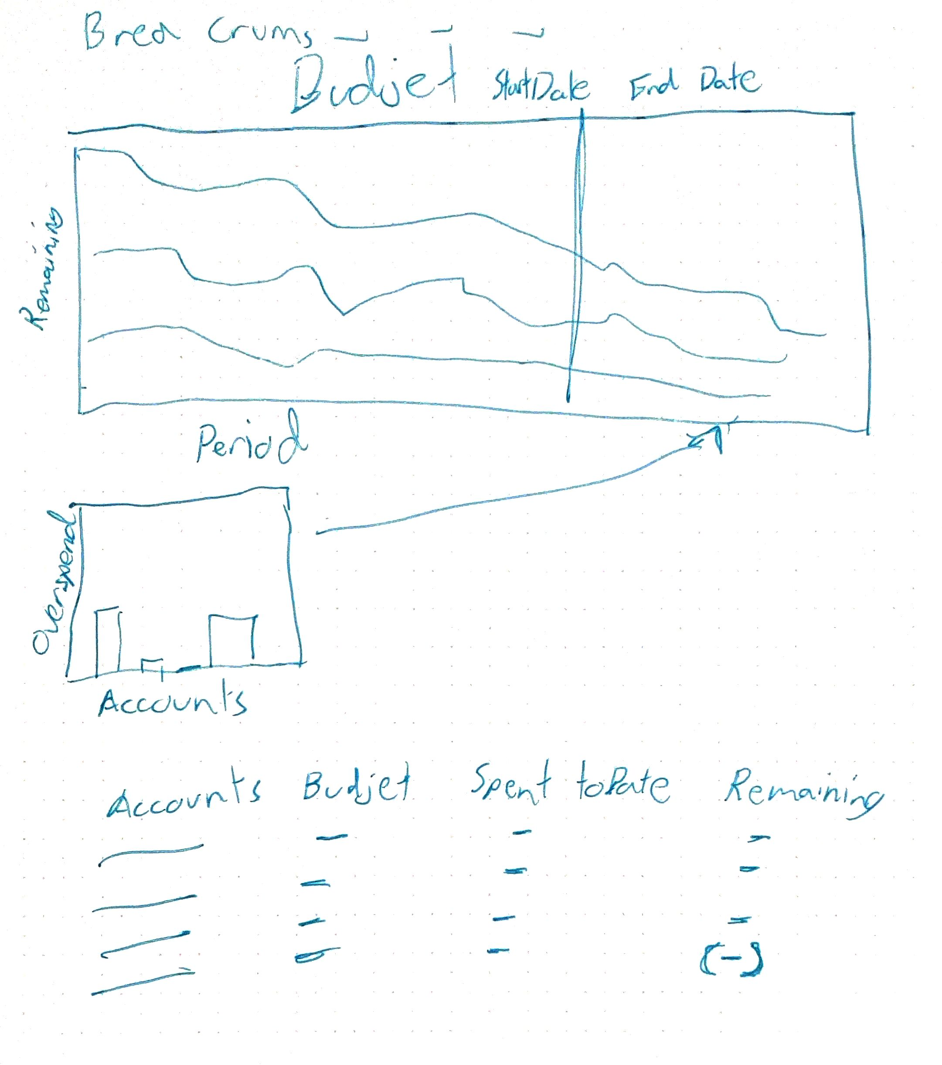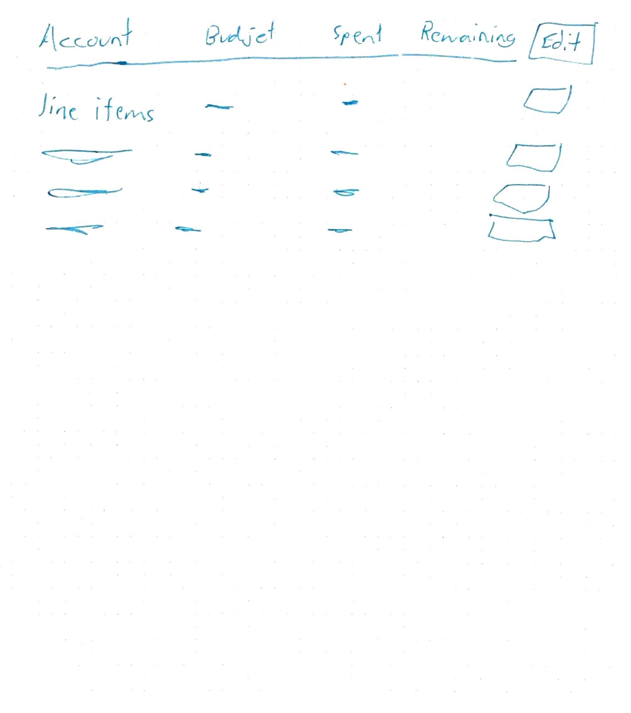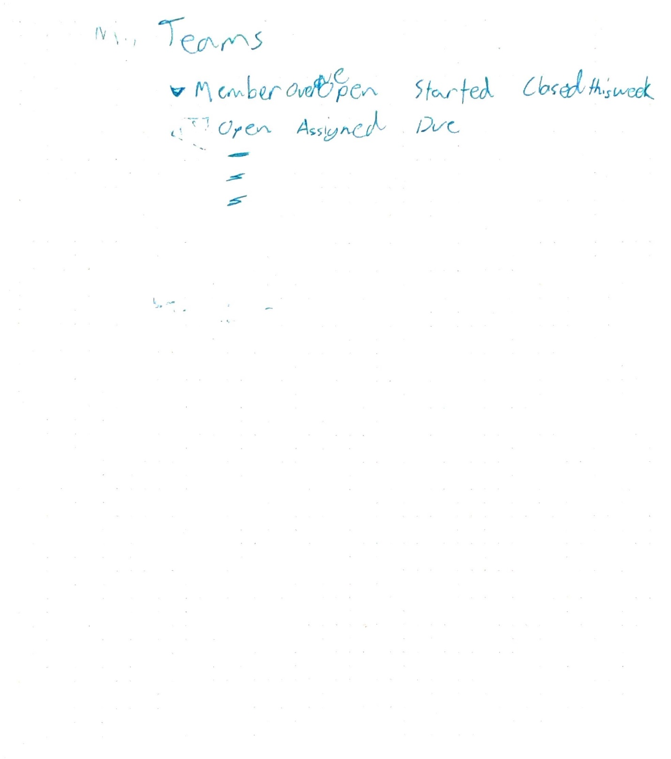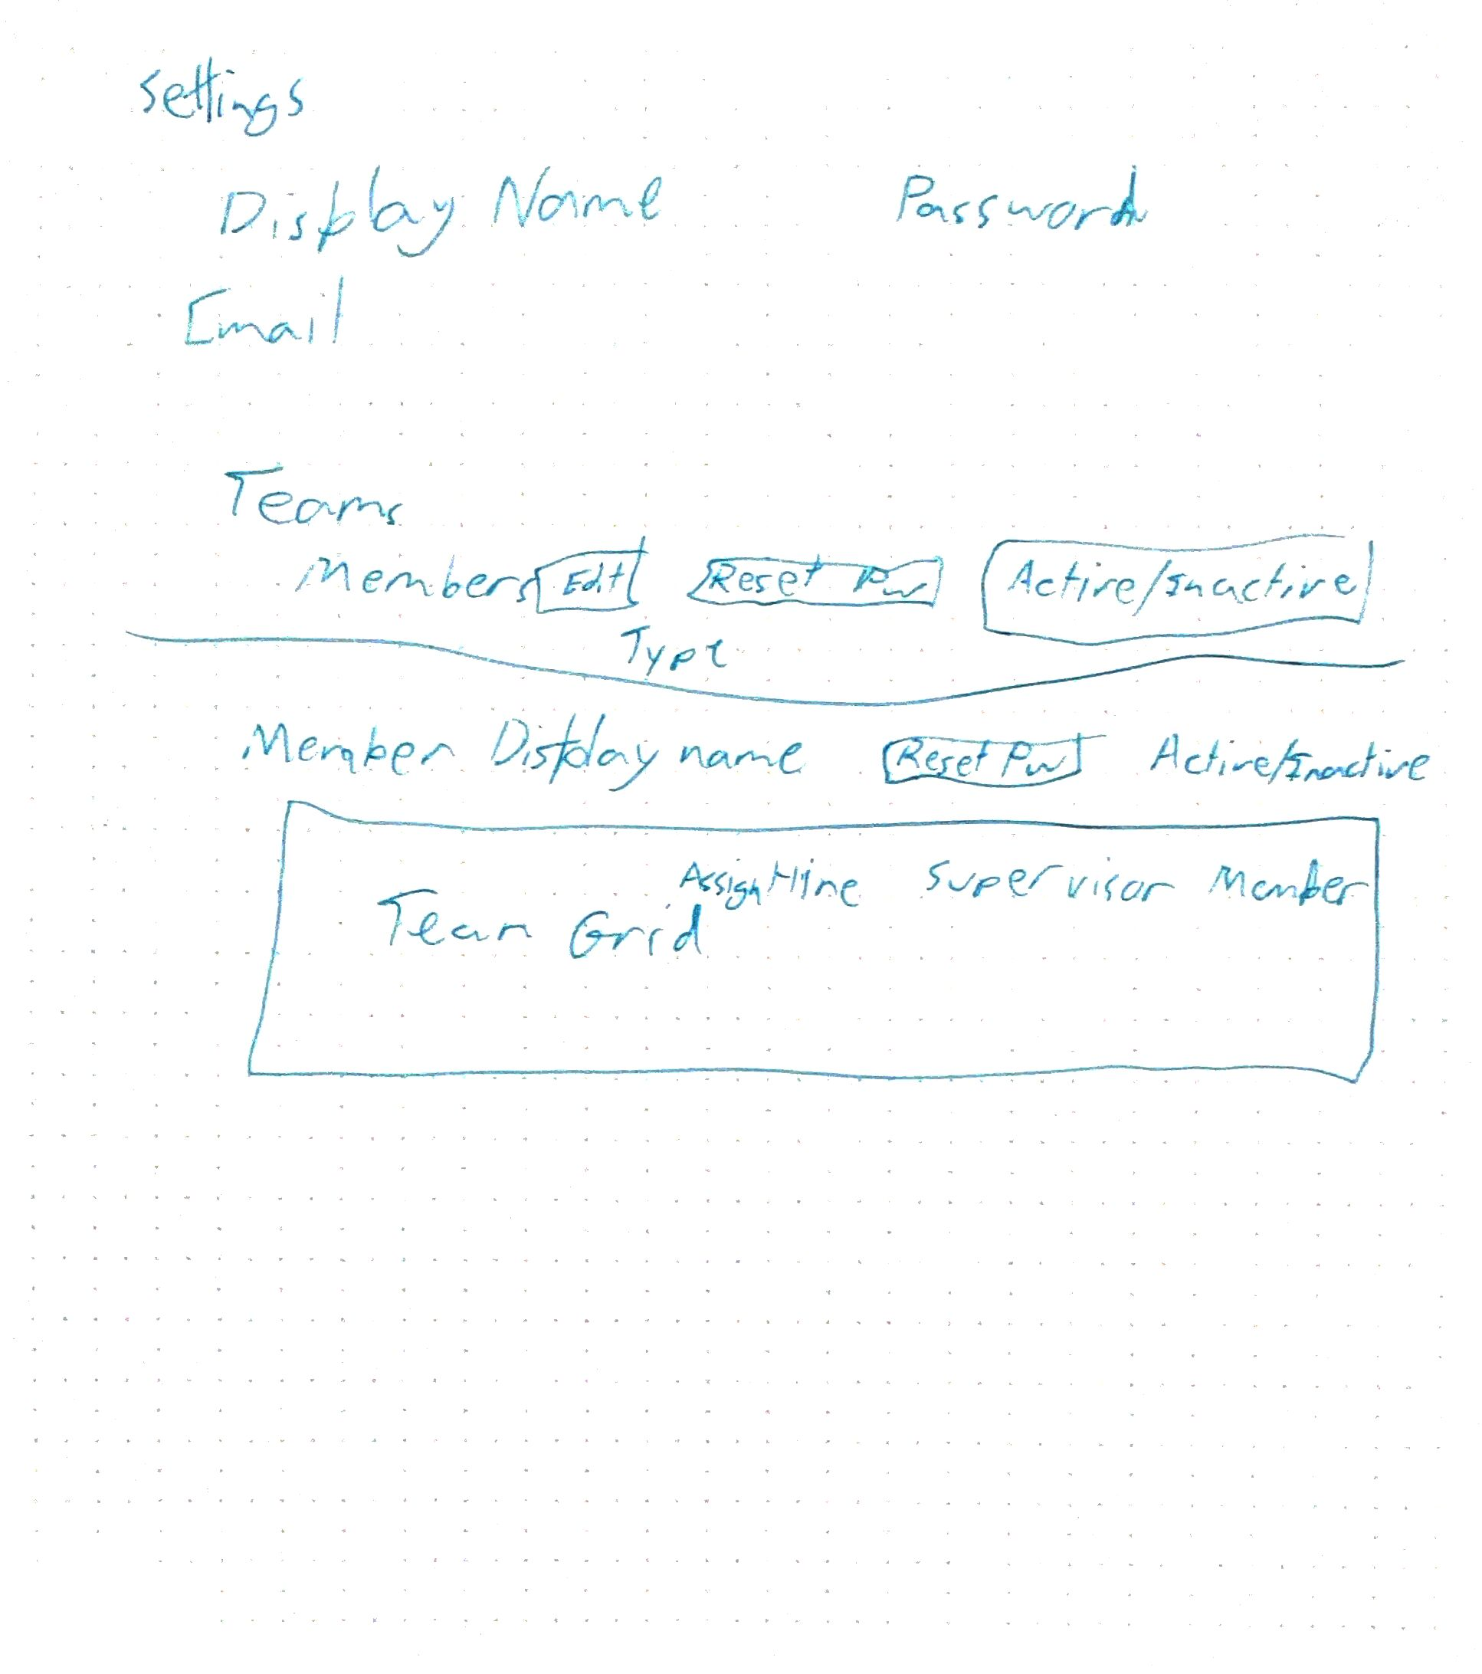

Final Sketches 